Official entry form for DRIVERS
(must be sent by e-mail not later than 7 days before event to Organizer)
 |   2015 – 3rd EVENT | 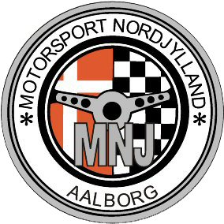

Date of event: 8-9 / 8 - 2015 place: Nysumbanen country: Denmark
ORGANIZER  Name: Klaus Knudsen  Address: Skovmarken 1  DK-9510 Arden Denmark  Phone +45 29 69 45 82  E-mail: klaus.s.knudsen@googlemail.com  Bank Account:  Reg nr:9314 konto nr:4584548423 |  | Start Nr.  Division for NEZ (X)
  NEZ SUPER 1600
  NEZ 2000
  NEZ Open
  NEZ SUPERCARS
ENTRANT  Name:  Country:  Address:  Licence Nr:  Tel:  Fax:  E-mail:  Signature: |  | DRIVER  Name:  Country:  Address:  Licence Nr:  Date of birth:  Tel:  Fax:  E-mail:  Signature:
Entry fee.  NEZ 120 Euro or 900 Dkr. |  | AMB  Transpondernr.:
Mark:
Model:
Mark of engine:
Capacity of engine (cm3):
Power (HP):
Min weight according regulations (Kg):
Real weight (Kg):
FIA Technical passport No:

